Social Link: The social link system in Persona X is more complicated than that of previous games. For simplicity's sake, this guide will first explain how to create a social link following the same mechanics as the previous Persona titles.

From the “Social Link” page, select an arcana from the drop-down list and you will be given a short description of the arcana's meaning. If you decide you wish to work on a Social Link of that arcana, click “Select”.

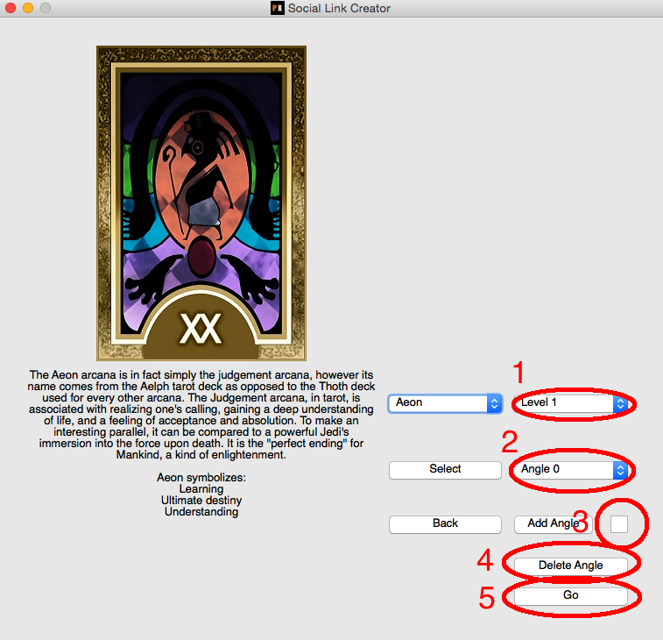

- 1: Level. Social Links are divided into 10 levels. Pick whichever level you wish to work on.

- 2: Angle. To create a Social Link following the same principles as those of previous games, enter “0” in the textbox and click “Add Angle”.

- 3: Adding angles. Enter the desired angle in the textbox and click “Add Angle”.

- 4: Delete Angle. In a simple Social Link, this will DELETE THIS LEVEL COMPLETELY! USE WITH CAUTION!

- 5: Go. Once you have selected your level and angle of choice (in simple case, Angle is 0), click “Go” to begin editing a cutscene for that level/angle.

If this is the first time you are accessing this particular cutscene, you should see:

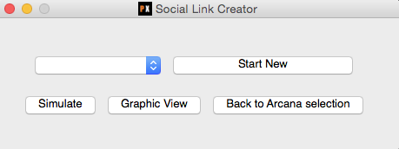

To begin working on a cutscene, click “Start New”.

The cutscene editor is divided into three parts: List View, Creation View and Graphic View.

List View: The simplest of the three, the List View supplies a drop-down menu of every single action taken in this cutscene. To edit any specific action, select if from that drop-down menu.

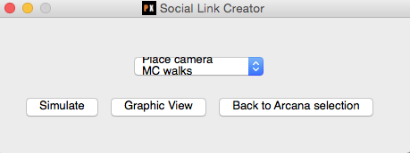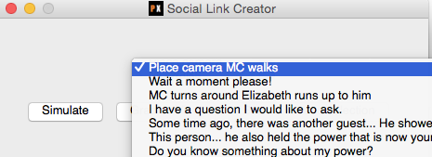

Edit View:

The edit view is what allows you to create and edit specific parts of the cutscene. There are a total of three different actions that can take place during a cutscene, “Speak”, “Camera Change” and “Movement”, however since absolute positioning is required to properly construct a camera change or movement, there is an additional “Info” action for your convenience. Unless you know what you are doing, please enter things like “Elizabeth is surprised” or “Pan camera to behind the MC” in an Info action.

-Speak actions are simply the dialogue to appear on the bottom of the screen. Select the speaker from the list of characters and write the text in the large text box. If you wish for this dialogue to add points towards the player's rank up in the social link you're working on, select the current arcana from the list and write the number of points in the textbox provided. For simple links following the same mechanics as previous games, that is all that is necessary.

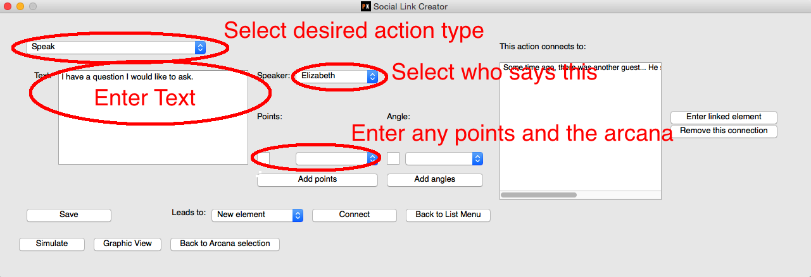

-Movement actions are a specific character moving to a certain point while performing a certain animation. Choose the character, the animation and enter the X and Y coordinates of the destination from the environment grid. As the environment grids are not provided with the program,

-Camera changes are used to move the characters to a new location. Simply choose the location from the drop-down list and enter the XYZ coordinates for the camera’s position and the point it is looking at.

-Info actions are simply a text box in which you may enter any extra information or requests concerning that part of the cutscene.

In a cutscene, one actions folows another. In other words, the character might say something, then say another thing. In order to link two actions together, the “Connect” button is used.



There are two different ways of connecting things. If you have created an element and then wish to create the element following that one (a very standard operation), make sure the drop-down menu is on “New element” and click connect. This will open a new action that is already linked to the first one. Once the second action is saved, it would look something like this:

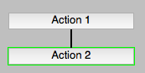

Of course, choices are a major part of what Social Links are. If you wish for there to be a player choice somewhere within you cutscene, connect multiple choices to any one action. For example, after connecting “Action 1” to “Action 2”, I returned to “Action 1” (through the graphic view or the list view) and then once again set the drop-down to “New element” and clicked “Connect”. The result look like this:

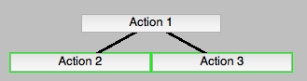

You could also want to have a pre-existing action follow the one you just made. In that case, select that element from the drop-down and click “Connect”. Please note that in order for this to stick, you must save the action again after connecting it. Linking something to a pre-existing action would look something like this (dotted line mean that “Action 4” leads to “Action 2”):

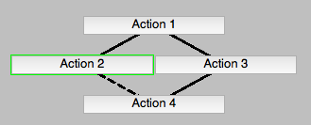

The graphical view is where the graphical representations like those above can be viewed. Click on “Graphic View” to access it. With a completed cutscene, it could look something like:

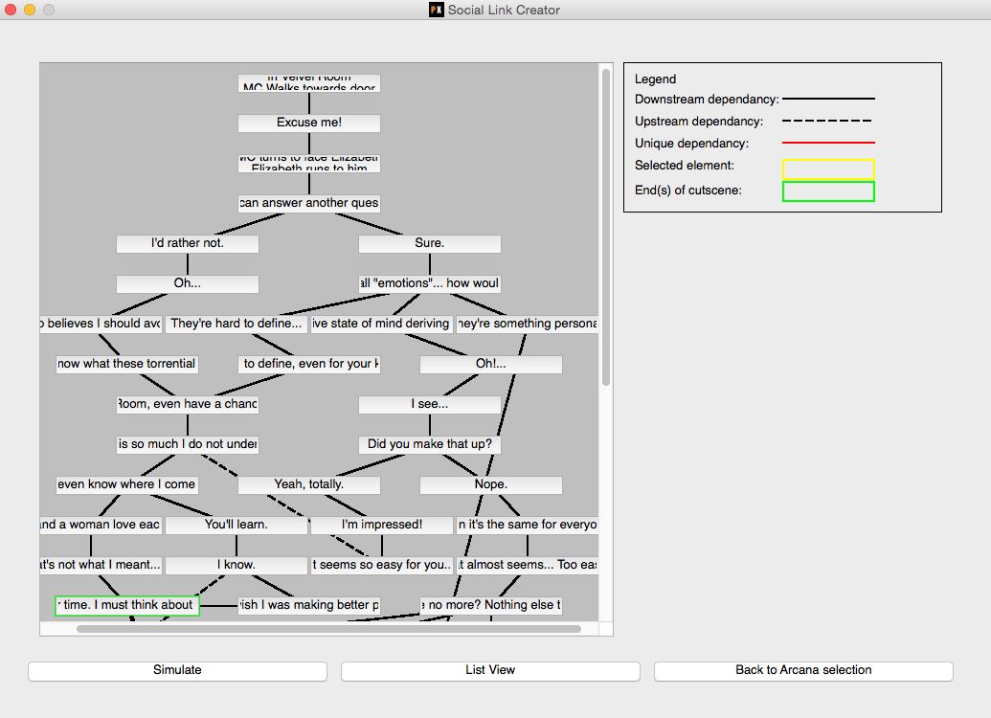

Downstream dependencies indicate that the higher item in the graph is followed by the lower item.

Upstream dependencies indicate the the lower item in the graph if followed by the higher item.

End(s) of cutscene are items that are NOT FOLLOWED by anything. As such, if the player reaches this point, the cutscene is over.

Upon selecting an action:

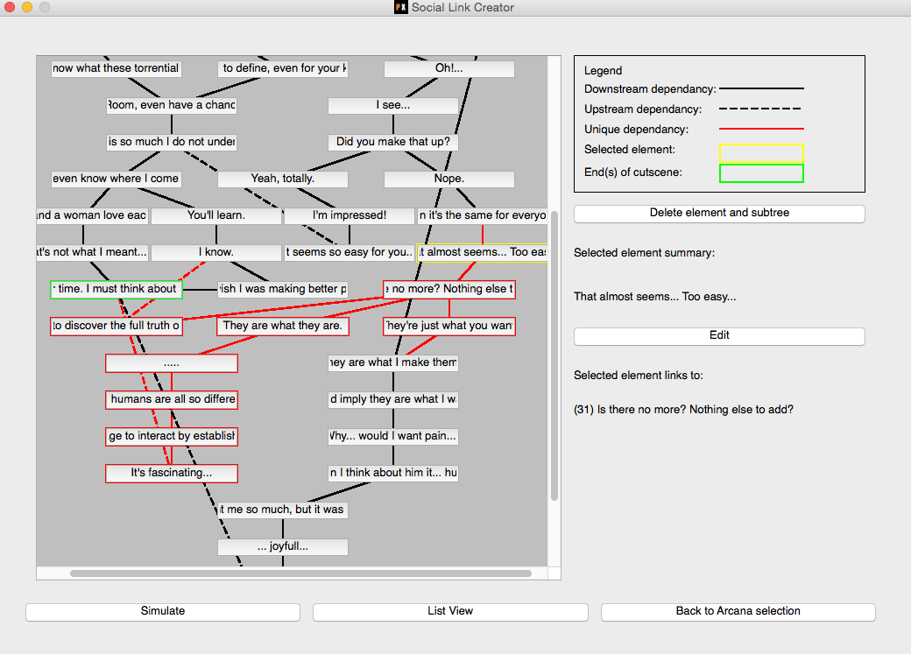

The Selected element summary will show you a brief sample of what that action represents. “Selected element links to” show the (index) and brief sample of any actions following the one selected.

Unique dependencies and deleting items and relations:

There should NEVER be unconnected or “floating” actions as they aren’t reachable by the player. As such, deleting an action will cause any items that cannot be reached without that action to also be remove. That is what a unique dependency is: an action or connection that cannot be reached ANY OTHER WAY than through the selected action. To delete an action, select it from the graphic view and click “Delete element and subtree”.

Deleting connections is done via the edit view. Select an element from the list and click “Remove this connection”. Just like deleting actions, this will result in ALL uniquely dependent actions being deleted. Unfortunately, you CANNOT select a connection in the graphic view so exercise even more caution when deleting connections.

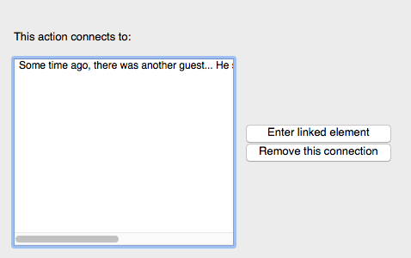

If you wish to delete an action or connection, please observe VERY carefully what the impact on your cutscene as a whole will be. It is strongly recommended you ALWAYS back up your cutscenes before deleting anything by going to Support/Contact in the Story Creator’s main menu and selecting “Export”.

The “Simulate” button will allow you to experience the cutscene you are currently working on. If you’d like to see some example cutscenes, arcana Aeon at level 1 angle 0 and level 2 angle 0 are complete and included with the program. Note that if that is the arcana you would like to work on, you are welcome to delete angle “0” on either of those.

**Things to keep in mind:**

1. Only characters that you have in your Story Creator program can be selected for Speak or Movement actions. Some default generic characters (“Classmate”, “Boy”, etc…) are provided, but you will no doubt have to make your own as well.
2. The start point, or root, of a cutscene is always the first action you create for it. It can be edited, but you cannot change the fact that it is that action that will be played first.
3. The proper way to introduce a character into a scene is by having them appear during loading at the start of a cutscene. It is important to consider that rotation of character is not bound in the movement action. You will have to provide a minimal movement from spawn point in order for the character to face in a direction.
4. The “beginning” of a cutscene will, with very few exceptions, start with placing the characters in a map. The proper way to do that is:
   1. Camera action (eg. Place camera in Velvet Room)
   2. Move actions (eg. MC moves to x, y Elizabeth moves to x, y)
   3. Camera action (Place camera in Loading)

Remember that as you are probably using “Info” actions for #3-4, you probably don’t need to consider it. The information provided in “Info” actions will be properly translated into Camera and Move actions.

1. The actions described in #4 are also valid for showing other places during the middle of a cutscene.
2. It is not unexpected to have multiple actions that are the same, especially in cases like characters going “…..”. If two actions are the same, a unique number will appear next to any duplicates in both the graphic view and the list view. Do not worry, that number will not show up in the cutscene (as you can see when simulating).
3. If you want the player to be able to react to a choice with a Move or Camera action, you should create a Speak action, assign it to the Narrator, and have that link to the Move/Camera action. This is so the player can see a blurb on what the choice encompasses in the choice selection list. If you don’t do this, there will be an empty selectable which would yield no indication to the player of what the choice encompasses.
4. The Story Creator is mainly for creating cutscenes and does not provide a means of planning out an entire Social Link. It is recommended you keep track of how many points and angles will lead to what result in a separate file (or an actual piece of paper).
5. For a list of places in the game along with a short description, please see ANNEX I.
6. If you want to completely lock a Social Link away from the player if he makes a wrong choice, don’t. But if you REALLY want to, give him a Speak action with -999999 points towards an arcana.
7. Feel free to contact us via “Support/Contact > Contact” is you have any questions or would like to do something unique that we hadn’t planned for!

**Advanced guide**

Angles: The most important feature added in the Persona X Social Link system is the concept of angles. Traditionally, tarot cards have different meanings depending on whether they are right-side up or upside down. This translates into a system where players can not only gain points towards the next Social Link level, but also give the link a certain angle. For visualization purposes, imagine the card that appears during the social link rank up scene rotating on itself to indicate its angle. This mechanic allows a less linear Social Link progression. It is not, however, *strictly necessary*. Note that the “path” that results in the reversed arcana should follow the reversed arcana`s meaning. A Social Link may be made to progress as those in *Persona 3* and *Persona 4* did by following the instructions in the previous section. To create a social link including the angle concept, consider the following:

*Add angle*: The add angle button pressed towards the beginning of the procedure indicates at what angle the cutscene you are about to create will be played. For example, if you enter “12”, the cutscene will only be played if the player has at least 12 “degrees” in this link. If no smaller values exist, this cutscene will be played if the angle value is at least 12 and anything under as well. When another angle is added, let’s say “15”, the cutscene with the angle “12” will be played for any angle values smaller than 14, and so on and so forth. *There is no limit to how many angles you may add*.

*Gaining “angle”*: As with points, angle can only be gained (or lost) during Speak actions. Next to the section into which you enter the points gained, there is another drop-down list and another text box. Select the appropriate arcana and enter the angle to add. *Important:* although it is named “angle”, there are no restrictions to quantity (you don’t need to stay within 180 degrees). During gameplay, the perfectly upright position (“0 degrees”) will always be the value of the smallest angle achievable during the final rank and the perfectly reversed position (“180 degrees”) will always be the value of the largest angle achievable during the final rank.

Losing points and angle: If you so desire, you may enter negative values in the point and angle fields of a speak action. This will cause the player to lose points towards the next level (making it longer to get to the end) or rotate the card back towards it’s upright position.

Points/angle for multiple arcanas: Another new feature is that it is now possible for a certain action or attitude to affect multiple different Social Links. In other words, the main character can gain or lose points and angle towards multiple different arcanas at once. To use this, click “Add Points” and/or “Add Angle” on the Speak edit view and select whichever arcana and whatever number of points/angle you wish.